SMART VENDING MACHINE USING AMAZON DRS

***A PROJECT REPORT***

***Submitted by***

# ABISHAK S (210417106001)

**HARIHARAN NKS (210417106002)**

***In partial fulfillment for the award of the degree***

***Of***

### BACHELOR OF ENGINEERING

***in***

### ELECTRONICS AND COMMUNICATION ENGINEERING

**CHENNAI INSTITUTE OF TECHNOLOGY CHENNAI 600 069**

# ANNA UNIVERSITY: CHENNAI 600025

### APRIL 2021

ANNA UNIVERSITY: CHENNAI 600 025

# BONAFIDE CERTIFICATE

Certified that this project report **“SMART VENDING MACHINE USING AMAZON DRS”** is the bonafide work of **“ABISHAK S (210417106001) and HARIHARAN NKS (210417106032)”** who carried out the project work under my supervision.

**SIGNATURE SIGNATURE**

**Dr. R MENAKA, Ph.D., Dr. R SURESH KUMAR, Ph.D.,**

**HEAD OF THE DEPARTMENT SUPERVISOR**

**Professor Assistant Professor**

Department of Electronics and Department of Electronics and

Communication Engineering Communication Engineering

Chennai Institute of Technology, Chennai Institute of

Technology, Kundrathur, Chennai – 600 069. Kundrathur, Chennai – 600 069.

Submitted for the Project Viva examination held on:

**INTERNAL EXAMINER EXTERNAL EXAMINER**

# ACKNOWLEDGEMENT

First of all, we bow our heads to the God Almighty for his everlasting grace in all our endeavors. It is a pleasure to thank the people who have made this project possible and have given their encouragement, assistance and support throughout the whole process of the completion of my project at Chennai Institute of Technology, Kundrathur.

We would like to express our sincere gratitude to our respected Chairman **Mr.**

**P. SRIRAM** for their valuable support and encouragement in technological upgrades and novel projects.

Our sincere thanks to **Dr. A. RAMESH B.E., M.E., Ph.D.,** Principal, Chennai Institute of Technology, for his valuable suggestions, moral support and encouragement towards completing this project work.

We express our gratitude to **Dr. R MENAKA Ph.D.,** Head of Department, Department of Electrical and Electronics Engineering, Chennai Institute of Technology, for guiding and encouraging during the project.

We would like to thank our supervisor **Dr. R SURESH KUMAR Ph.D.,** Assistant Professor, Chennai Institute of Technology, for his valuable guidance and help in my project work. He has provided his kind help from the very beginning of the project, to the end of the editing the last word of our project.

We are blessed to have the help and kindness of our class and the help and kindness of our classmates. Words cannot adequately express our appreciation for their patience, understanding and unconditional support during difficult times and their invaluable help in formatting this project. We also extend our gratitude to our family members for their constructive criticism in the day-by-day review.

# ABSTRACT

Existing replenishment system can only periodically review the inventories. Whereas, current vending machines cannot be capable of providing or determining if the supplies are able to replenishment or not. This results in an inefficient replenishment policy and there will be frequent stock-out among the products. This project aims to provide the automatic replenishment of Smart Vending Machine that will provide and support inventories to the administrator. Amazon Dash Replenishment Service (Amazon DRS) enables when the vending machine is about to run out of the stock inventory/product, it automatically places orders on Amazon, this gives the administrator which of the supplies need to replenishment. By Implementing this project, stock-out among the vending machines will be prevented and an efficient replenishment system can be implemented.

# TABLE OF CONTENT

|  |  |  |
| --- | --- | --- |
| **CHAPTER**  **NO** | **TITLE TABLE OF CONTENT LIST OF TABLES**  **LIST OF FIGURES**  **LIST OF ABBREVIATIONS** | **PAGE NO**  **iv vii viii x** |
| **1** | **INTRODUCTION** | **(1-4)** |
|  | 1.1 OVERVIEW OF THE SYSTEM | 1 |
|  | 1.2 OBJECTIVES OF THE PROJECT | 2 |
|  | 1.3 PROBLEM DEFINITION/STATEMENT | 2 |
|  | 1.4 BENEFITS OF PROJECT | 3 |
|  | 1.5 PROJECT SCOPES/ CONSTRAINS | 3 |
|  | 1.6 REPORT OUTLINE | 4 |
| **2** | **LITERATURE REVIEW** | **(5-9)** |
|  | 2.1 INTRODUCTION | 5 |
|  | 2.2 SURVEY REVIEW | 5 |
| **3** | **HARDWARE DESCRIPTION** | **(10-26)** |
|  | 3.1 REED SWITCH | 10 |
|  | 3.1.1 REED SWITCH OPERATION | 11 |
|  | 3.2 NEODYMIUM MAGNET | 12 |
|  | 3.3 16x2 I2C LCD DISPLAY | 12 |
|  | 3.3.1 Pin Description of LCD Display | 13 |

|  |  |
| --- | --- |
| 3.3.2 Features of LCD | 14 |
| 3.3.3 Registers of LCD | 16 |
| 3.3.4 INTERFACING I2C LCD WITH ESP32 | 17 |
| 3.4 ESP 32 | 18 |
| 3.4.1 ESP32 FUNCTIONAL BLOCK DIAGRAM | 19 |
| 3.5 GENERAL PURPOSE PCB | 20 |
| 3.6 JUMPER WIRES | 20 |
| 3.7 PUSH BUTTONS | 21 |
| 3.8 LED | 21 |
| 3.9 POWER SUPPLY | 22 |
| 3.9.1 COMPONENTS OF POWER SUPPLY UNIT | 22 |
| 3.9.2 WORKING OF POWER SUPPLY UNIT | 26 |
| **4 SOFTWARE DESCRIPTION** | **(27-32)** |
| 4.1 OVERVIEW ABOUT IoT | 27 |
| 4.2 ARDUINO IDE 1.8.5 | 30 |
| 4.3 LOGIN WITH AMAZON (LWA) | 31 |
| 4.3 AMAZON AWS SNS | 31 |
| 4.4 AMAZON DASH REPLENISHMENT SERVICE | 32 |
| **5 PROPOSED METHODOLOGIES** | **(33-36)** |
| 5.1 METHODOLOGY | 33 |
| 5.2 BLOCK DIAGRAM | 34 |
| 5.3 WORKING OF THE SYSTEM  5.4 FLOWCHART | 35  36 |

|  |  |
| --- | --- |
| **6 RESULT AND DISCUSSION** | **(37-40)** |
| **7 CONCLUSIONS** | **(41)** |
| **REFERENECE** | **(42-44)** |
|  |  |
|  |  |
|  |  |
|  |  |
|  |  |
|  |  |

**LIST OF TABLES**

|  |  |  |
| --- | --- | --- |
| **TABLE NO** | **TITLE** | **PAGE NO** |
| **Table 3.1** | Pin Description on LCD Display | (13-14) |
| **Table 3.2** | PINOUT I2C and ESP32 | 17 |

# LIST OF FIGURES

|  |  |  |
| --- | --- | --- |
| **FIGURE NO**  Fig 3.1 | **TITLE**  REED SWITCH | **PAGE NO**  10 |
| Fig 3.2 | Reed Switch Operation | 11 |
| Fig 3.3 | Neodymium Magnet | 12 |
| Fig 3.4 | I2C LCD DISPLAY | 13 |
| Fig 3.5 | Pin Diagram Of LCD | 15 |
| Fig 3.6 | Interfacing I2C LCD with ESP32 | 17 |
| Fig 3.7 | Function Block Diagram of ESP32 | 18 |
| Fig 3.8 | General Purpose PCB | 20 |
| Fig 3.9 | Jumper Wires | 20 |
| Fig 3.10 | Push Button | 21 |
| Fig 3.11 | Light Emitting Diode | 21 |
| Fig 3.12 | Block Diagram of Power Supply Unit | 22 |
| Fig 3.13 | Equivalent Circuit of Transformer | 23 |
| Fig 3.14 | In 4148 Bridge Wave Rectifier Diode | 24 |
| Fig 3.15 | Equivalent Circuit of Bridge Wave Rectifier | 24 |
| Fig 3.16 | IC 7805 | 25 |
| Fig 3.17 | IC7812 | 25 |
| Fig 3.18 | Equivalent Circuit of Voltage Regulators | 26 |
| Fig 4.1 | ARDUINO IDE LOGO | 30 |
| Fig 4.2 | Amazon SNS | 31 |
| Fig 4.3 | Amazon DRS | 32 |

|  |  |  |
| --- | --- | --- |
| Fig 5.1 | Block Diagram of the Proposal System | 34 |
| Fig 6.1 | Product Registration Web Page | 36 |
| Fig 6.2 | Demo photo of Project | 37 |
| Fig 6.3 | Config hosted by ESP32 | 38 |
| Fig 6.4 | ESP terminal Showing Successful replenishment process on trigged of reed switch | 39 |

**LIST OF ABBREVIATIONS**

**AWS** - AMAZON WEB SERVICE

**DRS** - DASH REPLENISH SERVICE

**SNS** - SIMPLE NOTIFICATION SERVICE

**SVM** - SMART VENDING MACHINEMENT SERVICE

**PCB** - PRINTED CIRCUIT BOARD

**LWA** - LOGIN WITH AMAZON

**LED** - LIGHT EMITTED DIODE

**LCD** - LIQUID CRYSTAL DISPLAY

**I2C** - INTER INTEGRATED CIRCUIT

**RAI** - RESUPPLY ALERT INDEX

**EWS** - EARLY WARNING SYSTEM

**SMS** - SHORT MESSAGE SYSTEM

# CHAPTER-1

# INTRODUCTION:

* 1. **OVERVIEW OF THE SYSTEM:**

Vending machines are used to provide convenience for consumers and it has now become an essential component of consumer lifestyles. However, service functions go on a procedure towards society and the public, and studies about improving its operation and function have been conducted.

Due to an increasing competitive environment and shortened product life cycle in the vending machine industry, more attention has been paid to the collaboration between members of a supply chain focusing on the increasing interest in the development of replenishment policy.

Having a better replenishment policy is a key component to fit in with frequency and quality control. Traditional replenishment process is based on the estimation from historical inventory records. Problem arises in this existing approach when using periodic review policy to replenish the goods of the vending machines for it is only suitable when the demand is very stable and the replenishment cost is high; the demand of products is fluctuating in a vending machine. In this project, the use of Amazon DRS becomes an advantage by making the vending machine automatically replenishment the inventories by placing orders on Amazon via DRS service efficiently.

## OBJECTIVES OF THE PROJECT:

Smart Vending Machine using Amazon DRS can be used in many ways as follows:

* + - Main Objective of the project, is to design low-cost Smart Vending machine by utilizing ESP32 and
    - demonstrate end to end use case of Amazon DRS Service with easy and interactive end user interaction.
    - It will automatically replenish the product of vending machines easily form Amazon.com through Amazon DRS service.
    - It will be best suited for the small-scale Vending machines such as Snacks Vending machine, Beverage Vending machine, Sanitary needs Vending machine.
    - Reduces the relationship between the admin/owner of the Vending machine and supplier to the minimal level.

# PROBLEM STATEMENT/DEFINITIONS:

Nowadays Vending Machines use has been increased drastically which is making easy convenience to consumers and providers. Existing replenishment services of vending machines are high cost, not easy to implement and use by laymen. Having a better replenishment policy is a key component to fit in with frequency and quality control.

One vending machine produces on average a total of Rs.6000 of revenue each week for whoever owns and operates the machine. That amounts to over Rs.25000 per month. So you can see how several machines producing an average start bringing in nice profits and in nice locations. Set up of initial entry level vending machines may cost from between Rs.2L-3L in India. But in this type of vending we cannot see automatic replenishment service for this cost.

And, Traditional replenishment process is based on the estimation from historical inventory records. Problem arises in this existing approach when using periodic review policy to replenish the goods of the vending machines for it is only suitable when the demand is very stable and the replenishment cost is high; the demand of products is fluctuating in a vending machine. Whereas for Small Vending Machines there is no replenishment service in the market because they are neglected to provide the service.

# BENEFITS OF THE PROJECT:

* + - It is cost effective
    - Easy to Implement in existing Vending Machine
    - Reduction of admin/owner and provider gap relation
    - Useful for existing low cost entry level Vending Machine

# PROJECT SCOPES / CONSTRAINTS:

**Amazon Dash Replenishment Service (Amazon DRS)** enables when the vending machine is about to run out of the stock inventory/product, it automatically places orders on Amazon, this gives the administrator which of the supplies needed replenishment. By Implementing this project, stock-out among the vending machines will be prevented and an efficient replenishment system can be implemented. We are going to design a vending box which will have three slots each for inventories. The **Dash Replenishment Service (DRS)** uses **Simple Notification Service (SNS)** Topics to notify you (the device maker) of changes to device status, order state, subscription status, and more. And **Login with Amazon (LWA)** lets you protect your customer information by leveraging the user authentication system used by Amazon.com. Login with Amazon is based on **OAuth 2.0**, which has been broadly adopted for user authorized exchanges across

sites. Listed with unique **ASINs (Amazon Standard Identification Number)** of inventories will be mapped with each slot in DRS API.

# REPORT OUTLINE:

The project contains a total of 8 chapters. Chapter 1 tells about the overview and problems to be overcomes and benefits, and objectives of the project. In Chapter 2, we discuss the literature survey in detail. Chapter 3 and 4 explains about the Hardware description and Software description respectively. In Chapter 5, we discuss in detail about the methodology, block diagram and working of the system. In Chapter 6, we discuss results and discussion. The conclusion is discussed in Chapter 7. The reference papers and links are given Chapter 8.

# CHAPTER 2 LITERATURE REVIEW

* 1. **INTRODUCTION:**

In order to design, develop and to implement this system, several theoretical and technological surveys are made with previous papers. The review includes the technological development and control methods that are used in our project.

# EXISTING METHODOLOGY:

1. **IoT An Overview**

Information and Communications Technology (ICT) controls our daily behavior’s. It becomes a main part of our life critical infrastructure bringing interconnection of heterogeneous devices in different aspects. As a critical living entity, the Internet is contentiously changing and evolving leading to emerging new technologies, applications, protocols and algorithms. Acceleration of wireless communication trends brings an ever-growing innovation in Internet connectivity and mobile broadband. Infrastructure-less communication devices become ubiquitous, smart, powerful, connectible, smaller, cheaper, and easier to deploy and install. This opens a new future direction in the society of ICT: the Internet of Things (IoT). Nowadays, the IoT, early defined as Machine-to-Machine (M2M) communications, becomes a key concern of the ICT world and research communities. In this paper, we provide an overview study of the IoT paradigm, its concepts, principles and potential benefits. Specifically, we focus on the IoT major technologies, emerging protocols, and widespread applications. This overview can help those who start approaching the IoT world aiming to understand and participate in its development.

# Fuzzy Logic Based Replenishment System for Smart Paper Dispensing Machine

Existing replenishment systems in vending machines can only periodically review the inventories. Moreover, current vending machines are not capable of determining if the supplies are subject to replenishment or not. This results in an inefficient replenishment policy and there will be frequent stock-out among the products. This research aims to develop a smart vending machine that provides inventory and logistic support for the operator. The intelligent system is controlled by a fuzzy system which outputs the crisp values which will be represented by the Resupply Alert Index (RAI), a decimal number representation that ranges from 0-3 with 0 as ‘urgent’ status and 3 as ‘ok’ status; this gives the operator which of the supplies needs replenishment. By implementing this study, stock-out among the vending machines will be prevented and an efficient replenishment system will be implemented. The application used for the implementation of this system is a paper dispensing machine that covers the demand in the Faculty of Engineering of the University Of Santo Tomas and compared with other virtual simulations. Through the simulations, it was established that the RAI can give the supplier the information of which vending machine and which of its products has the highest replenishment urgency.

# Smart Vending Machine Based on SMS Gateway for General Transaction

This paper presents design and experimental studies of vending machines for office stationery Transactions. The advantage of the proposed vending machine i.e., Transaction can be done by using short message system (SMS), all transaction can be monitored online by owner by using Android, the vending machine has feature early warning system (EWS) when system in trouble, and it also equipped with battery backup when electricity cut off, no need to make special agreement with bank or telecommunication provider. The Smart Vending Machine is built by using common hardware components such as Arduino as controller, Wave come as SMS Gateway module, Servos, Power Supply, Battery as power back up, Keypad and button as input, LCD 16x2 as Display. From the several tests including normal transaction, online monitoring, and early warning system for electricity supply. The Smart Vending Machine was successful. And it has a big possibility to be mass

Production.

# A Design of Smart Unmanned Vending Machine for New Retail Based on Binocular Camera and Machine Vision

The smart unmanned vending machine using machine vision technology suffers from the sharp decrease of detection accuracy due to the incomplete image collection of items by monocular camera in complex environments, and the lack of obvious features in dense stacking of items. In this paper, a binocular camera system is designed to effectively solve the problems of distortion and coverage caused by monocular cameras. Besides, an image-stitching algorithm is developed to splice the images captured by the camera, which relieves the burden of computation for back-end recognition processing brought by the binocular camera. A new model YOLOv3-TinyE is proposed based on the YOLOv3-tiny model.

# Fingerprint Improves the Payment Experience of a Drink Vending Machine

Many examples of technology on the payment scheme already help and facilitate transactions in Indonesia such as internet banking, ATM or debit cards, e-money, and also mobile banking. Included on the drink vending machine, it is a sale that utilizes machines. Today’s commonly, drink vending machines still use coins or smart cards, which based on the Legal and Ethical Experience this factor still have many weaknesses and threats that can occur in this payment system. So the payment authentication factor is needed to pay more attention to user experience components, some of which are ownership, privacy, and security.So that in this study, the implementation of the fingerprint authentication scheme was made as an e payment factor based on user experience. This study uses a mixed-method in analyzing every pain problem of the research. Where to conduct exploratory studies through literature review and direct observation in the case of the application of the vending machines, especially in developing countries such as Indonesia.

This research shows that the payment authentication system can solve the problem of the risk of system attack, the risk of topping up fails, it can harm the user, if the user loses a smart card, the smart card is at risk of being used by not the owner, if the data on the smart card is cloned, it can poses a risk to the system. The conclusion of the proposed payment system can overcome the existing problems obtained from the system security testing scenario. In addition, user agreement testing is also done by providing a questionnaire comparing the level of satisfaction of the existing and proposed payment systems, the results of this test shows that the user feels comfortable with the proposed payment system. Index Terms—Payment, Biometric, Fingerprint.

# IoT Based Vending Machine with Cashless Payment

A vending machine is an automated machine that provides items such as snacks and lottery tickets to consumers after money, a credit card or specially designed card is inserted into the machine. This concept can be implemented using cashless payment. Even after reaching the spot the process takes additional time for locating, and billing process. Another disadvantage of the current system involves money which has several problems. A user always has to carry money with him which is not a good option in today’s era as every money transfer takes place in the form of digital transaction. Also, there is a possibility in the theft of money. We hereby present a solution where the payment part is bypassed to the online sources. Here we are solving an intricate problem with a simple algorithm providing an interface to the user that even a layman can easily understand.

# CHAPTER 3 HARDWARE DESCRIPTION

* 1. **REED SWITCH:**

The reed switch is an electrical switch operated by an applied magnetic field. It was invented at Bell Telephone Laboratories in 1936 by W. B. Ellwood.

It consists of a pair of contacts on ferrous metal reeds in a hermetically sealed glass envelope. The contacts may be normally open, closing when a magnetic field is present, or normally closed and opening when a magnetic field is applied.The switch may be actuated by a coil, making a reed relay, or by bringing a magnet near to the switch. Once the magnet is pulled away from the switch, the reed switch will go back to its original position.

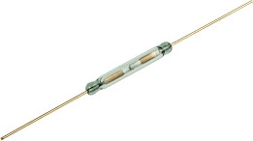

# Fig 3.1 REED SWITCH

* + 1. **REED SWITCH OPERATION:**

The simplest magnetic-field sensor is a reed switch. It contains two ferromagnetic nickel and iron reed elements in an evacuated, hermetically sealed glass tube to minimize contact arcing. When an axially aligned magnet approaches the switch, its magnetic force closes the reeds. The magnet typically generates at least a 50 Gauss force to overcome the return force or spring of the reed elements.

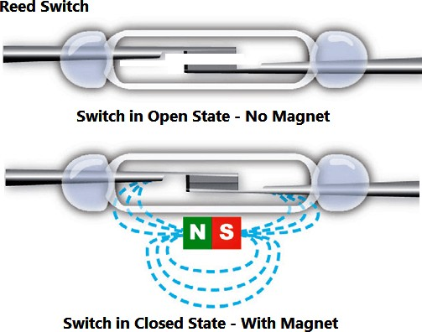Reed switches are inexpensive, require no standby power, and can function with both ac and dc electrical loads. However, they are relatively slow, so they may not respond fast enough for some high-speed applications. Since the switches are mechanical devices with moving parts, they have a finite number of operating cycles before they eventually fail. Switching high-current loads can further reduce life expectancy. Also, low-cost reed switches occasionally deliver unwanted, multiple switching points as the twin lobes of certain magnets pass by.

# Fig 3.2 Reed switch operation

* 1. **NEODYMIUM MAGNET:**

A neodymium magnet (also known as NdFeB, NIB or Neo magnet) is the most widely used type of [rare-earth magnet](https://en.wikipedia.org/wiki/Rare-earth_magnet). It is a [permanent magnet](https://en.wikipedia.org/wiki/Magnet) made from an [alloy](https://en.wikipedia.org/wiki/Alloy) of [neodymium](https://en.wikipedia.org/wiki/Neodymium), [iron](https://en.wikipedia.org/wiki/Iron), and [boron](https://en.wikipedia.org/wiki/Boron).

**Neodymium magnets** are particularly **used** in hard disc drives, mobile phones, video and audio systems of television. **Neodymium magnets** are also commonly **used** in **magnetic** separators, filters, ionizers, in production of on–off buttons, safety sector and security systems.

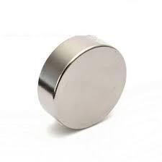

# Fig 3.3 Neodymium Magnet

* 1. **16x2 I2C LCD DISPLAY:**

The LCD display shown in Figure 3.4 is used for displaying information about the Vending machine. It is simply used for displaying purpose. I2C LCD Display is an easy-to-use display module, It can make display easier.

Using I2C LCD, displaying each slot count status, configuration of DRS for registration, WIFI / network status of the vending machine.

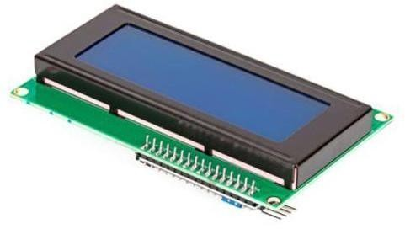

**Fig 3.4 I2C LCD DISPLAY**

* + 1. **Pin Description of LCD Display:** *(shown in fig 3.5)*

These are the pin representations.

|  |  |
| --- | --- |
| Pin1 (Ground/Source Pin): | This is a GND pin of display, used to connect the GND terminal of the micro-controller unit or power source. |
| Pin2 (VCC/Source Pin): | This is the voltage supply pin of the display, used to connect the supply pin of  the power source. |
| Pin3 (V0/VEE/Control Pin): | This pin regulates the difference of the display, used to connect a changeable POT that can supply 0 to 5V. |
| Pin4 (Register Select/Control Pin): | This pin toggles among command or data register, used to connect a micro-controller unit pin and obtains either 0 or 1(0 = data mode, and 1 = command mode). |

|  |  |
| --- | --- |
| Pin5 (Read/Write/Control Pin): | This pin toggles the display among the read or writes operation, and it is connected to a micro-controller unit pin to get either 0 or 1 (0 = Write Operation, and 1= Read Operation). |
| Pin 6 (Enable/Control Pin): | This pin should be held high to execute the Read/Write process, and it is connected to the micro-controller unit and constantly held high. |
| Pins 7-14 (Data Pins): | These pins are used to send data to the display. These pins are connected in two-wire modes like 4-wire mode and 8-wire mode. In 4-wire mode, only four pins are connected to the micro-controller units like 0 to 3, whereas in 8-wire mode, 8- pins are connected to micro-controller units like 0 to 7. |
| Pin15 (+ve pin of the LED): | This pin is connected to +5V |
| Pin 16 (-ve pin of the LED): | This pin is connected to GND. |

# Features of LCD:

* + - * The features of this LCD mainly include the following.
      * The operating voltage of this LCD is 4.7V-5.3V.
      * It includes two rows where each row can produce 16- characters.
      * The utilization of current is 1mA with no backlight
      * Every character can be built with a 5×8-pixel box
      * The alphanumeric LCDs alphabets & numbers
      * Is display can work on two modes like 4-bit & 8-bit
      * These are obtainable in Blue & Green Backlight
      * 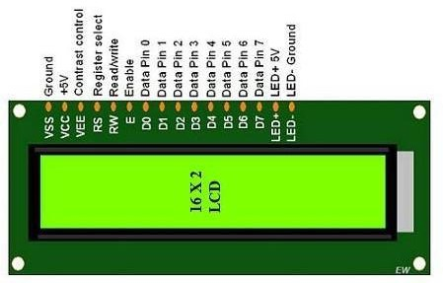It displays a few custom generated characters.

**Fig 3.5 PIN Diagram of LCD**

* + 1. **Registers of LCD:**

A 16×2 LCD has two registers like data register and command register. The RS (register select) is mainly used to change from one register to another. When the register set is ‘0’, then it is known as the command register. Similarly, when the register set is ‘1’, then it is known as a data register.

# Command Register:

The main function of the command register is to store the instructions of command which are given to the display. So that predefined tasks can be performed such as clearing the display, initializing, set the cursor place, and display control. Here commands processing can occur within the register.

# Data Register:

The main function of the data register is to store the information which is to be exhibited on the LCD screen. Here, the ASCII value of the character is the information which is to be exhibited on the screen of the LCD. Whenever we send the information to LCD, it transmits to the data register, and then the process will be starting there. When register set =1, then the data register will be selected.

# INTERFACING I2C LCD WITH ESP32:

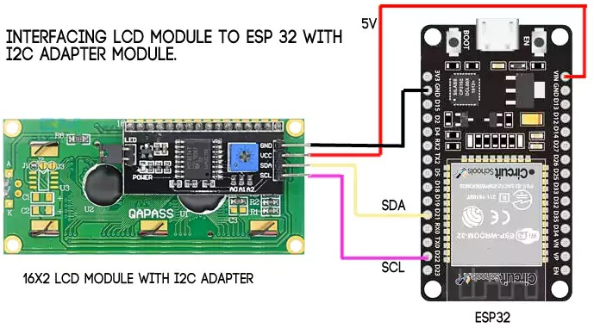

|  |  |
| --- | --- |
| **I2C LCD** | **ESP32** |
| GND | GND |
| VCC | 3.3/VIN |
| SDA | GPIO21 |
| SCL | GPIO22 |

**Fig 3.6 Interfacing I2C LCD with ESP32**

**Table 3.2 PINOUT I2C and ESP32**

* 1. **ESP32:**

ESP32 is a series of low-cost, low-power [systems on chip](https://en.wikipedia.org/wiki/System_on_a_chip) [microcontrollers](https://en.wikipedia.org/wiki/Microcontroller) with integrated [Wi-Fi](https://en.wikipedia.org/wiki/Wi-Fi) and dual-mode [Bluetooth](https://en.wikipedia.org/wiki/Bluetooth). The ESP32 series employs a [Tensilica](https://en.wikipedia.org/wiki/Tensilica) Xtensa LX6 microprocessor in both dual-core and [single-core](https://en.wikipedia.org/wiki/Single-core) variations and includes built-in antenna switches, RF [balun](https://en.wikipedia.org/wiki/Balun), power amplifier, low-noise receive amplifier, filters, and power-management modules. ESP32 is created and

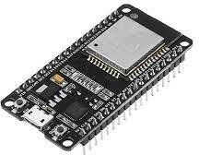

**Fig 3.2 ESP 32**

developed by [Expressive Systems](https://en.wikipedia.org/w/index.php?title=Espressif_Systems&action=edit&redlink=1), a Shanghai-based Chinese company, and is manufactured by [TSMC](https://en.wikipedia.org/wiki/TSMC) using their 40 nm process.

It is a successor to the [ESP8266](https://en.wikipedia.org/wiki/ESP8266) micro-controller. The prototyping hardware typically used is a circuit board functioning as a dual in-line package (DIP) which integrates a USB controller with a smaller surface-mounted board containing the MCU and antenna. The pin configuration of the ESP32 is given in the Table 3..The choice of the DIP format allows for easy prototyping on breadboards.

# ESP32 FUNCTIONAL BLOCK DIAGRAM:

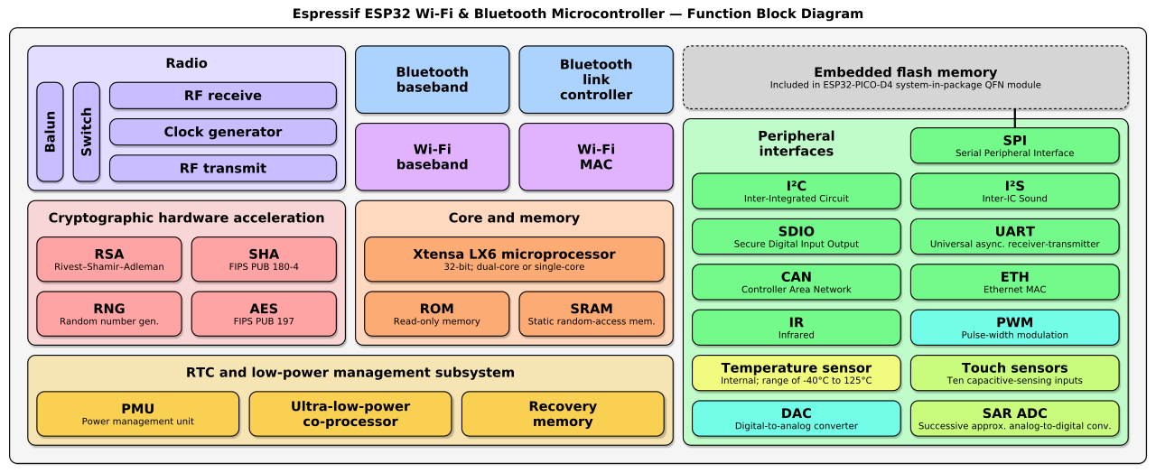

**Fig 3.7 function block diagram esp32**

# GENERAL PURPOSE PCB:

A **printed circuit board**, or **PC** board, or **PCB**, is a non-conductive material with conductive lines printed or etched. Electronic components are mounted on the board and the traces connect the components together to form a working circuit or assembly.

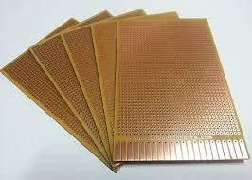

# Fig 3.8 General Purpose PCB

* 1. **JUMPER WIRES:**

Jumper wires shown in Fig 3.14 are used for connection between two components. It acts as a connector in between all the components.

# 

**Fig 3.9 Jumper Wires**

* 1. **PUSH BUTTON:**

A **push-button** (also spelled pushbutton) or **simply button** is a simple switch mechanism to control some aspect of a machine or a process Buttons are typically made out of hard material, usually **plastic** or **metal.**

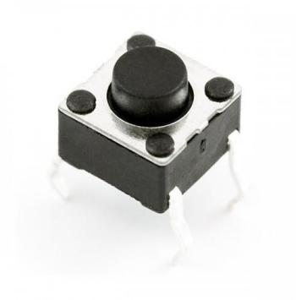

**Fig 3.10 Push Button**

* 1. **LED (Light Emitted Diode) :**

A **light-emitting diode (LED)** is a semiconductor light source that emits light when current flows through it. **LED**, in full light-emitting diode, in electronics, a semiconductor device that emits infrared or visible light when charged with an electric current.

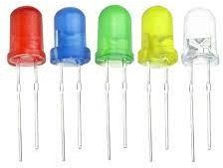

## Fig 3.11 Light emitted diode

### POWER SUPPLY UNIT:

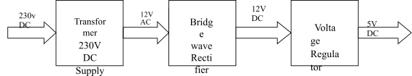

**Figure 3.12 BLOCK DIAGRAM OF POWER SUPPLY UNIT**

### COMPONENTS OF POWER SUPPLY UNIT:

A Block of the Power Supply unit is shown in Fig 3.12 consists mainly of three Components, they are

* Transformer
* Bridge wave Rectifier
* Voltage Regulator

### TRANSFORMER:

In the power supply unit, we use step down transformers because 230 V DC voltage should be converted to 12 V AC voltage.

### Equivalent circuit

Referring to Fig 3.13, a practical transformer's physical behavior may be represented by an [equivalent circuit](https://en.wikipedia.org/wiki/Equivalent_circuit) model, which can incorporate an ideal transformer.

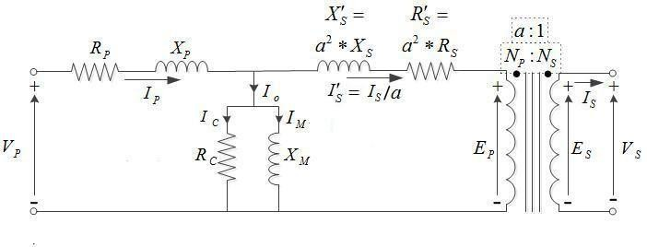

### Figure 3.13 EQUIVALENT CIRCUIT OF TRANSFORMER

Winding joule losses and leakage reactances are represented by the following series loop impedances of the model:

* + - * + Primary winding: RP, XP
        + Secondary winding: RS, XS.

In the normal course of circuit equivalence transformation, RS and XS are in practice usually referred to the primary side by multiplying these impedances by the turns ratio squared, (NP/NS) 2 = a2.

### BRIDGE WAVE RECTIFIER:

We use 1N 4148 diode which is shown in Fig 3.14 as bridge wave rectifier. This diode is a High speed switching diode. The rectifier is used for converting AC Voltage to DC Voltage whose equivalent circuit is shown in the Fig 3.15.

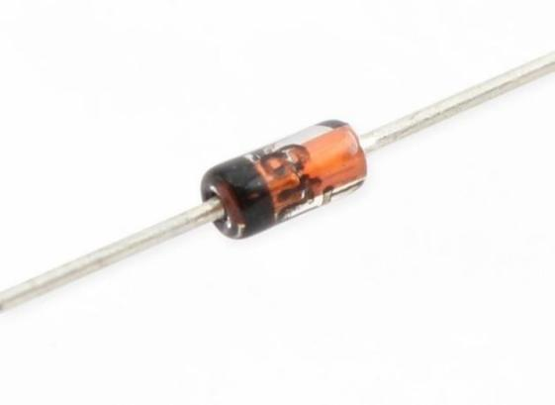

### Figure 3.14 1N-4148

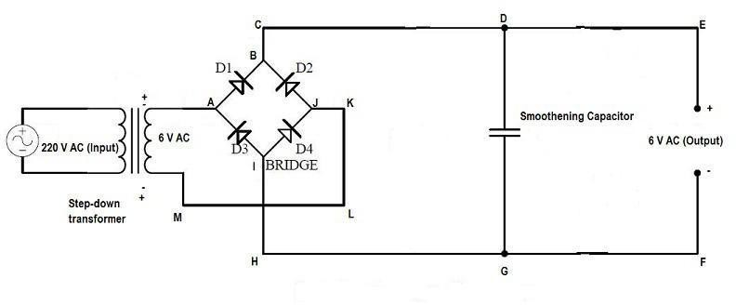

* + - 1. **VOLTAGE REGULATOR:**

Voltage regulator, any electrical or electronic device **that maintains the voltage of a power source within acceptable limits.** The voltage regulator is needed to keep voltages within the prescribed range that can be tolerated by the electrical equipment using that voltage. Here we use 2 voltage regulators whose pin diagrams are shown in Fig 3.16 and 3.17 also Fig 3.18 shows the equivalent circuit of the voltage regulators.

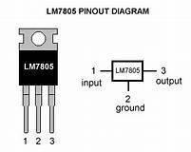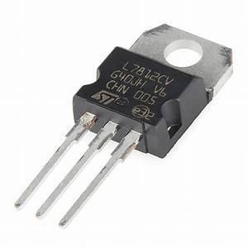

### Figure 3.16 IC7805 Figure 3.17 IC781

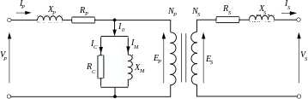

**Figure 3.18 Equivalent circuit of Voltage Regulator**

### WORKING OF POWER SUPPLY UNIT:

The 230V DC Supply is given to the transformer. The transformer gives 12V AC. In order to get DC voltage, we use Bridge wave rectifiers (IC 4148) in it. The Rectifier converts the AC Voltage to the DC Voltage. Thus, 12V AC supply is then converted to 12V DC supply. Out of the 12V power supply, we need 5V. So as to regulate the Voltage we use Positive Voltage Regulator (IC7805 & IC7812). Finally, we get 5V which is used for NODE MCU.

# CHAPTER 4 SOFTWARE DESCRIPTION

* 1. **OVERVIEW ABOUT INTERNET OF THINGS:**

The Internet of things (IoT) is a system of interrelated computing devices, mechanical and digital machines provided with unique [identifiers](https://en.wikipedia.org/wiki/Identifiers) (UIDs) and the ability to transfer data over a network without requiring human-to-human or human-to-computer interaction. The definition of the Internet of things has evolved due to the convergence of multiple technologies, real-time [analytics](https://en.wikipedia.org/wiki/Analytics), [machine](https://en.wikipedia.org/wiki/Machine_learning) learning, [commodity](https://en.wikipedia.org/wiki/Commodity) [sensors](https://en.wikipedia.org/wiki/Sensors), and [embedded systems](https://en.wikipedia.org/wiki/Embedded_system).

Traditional fields of [embedded systems](https://en.wikipedia.org/wiki/Embedded_system), [wireless sensor networks](https://en.wikipedia.org/wiki/Wireless_sensor_network), [control systems](https://en.wikipedia.org/wiki/Control_system), [automation](https://en.wikipedia.org/wiki/Automation) (including [home](https://en.wikipedia.org/wiki/Home_automation) and [building automation](https://en.wikipedia.org/wiki/Building_automation)), and others all contribute to enabling the Internet of things. In the consumer market, IoT technology is most synonymous with products pertaining to the concept of the "[smart home](https://en.wikipedia.org/wiki/Smart_home_technology)", covering devices and [appliances](https://en.wikipedia.org/wiki/Home_appliance) (such as lighting fixtures, [thermostats](https://en.wikipedia.org/wiki/Thermostats), home [security systems](https://en.wikipedia.org/wiki/Security_systems) and cameras, and other home appliances) that support one or more common ecosystems, and can be controlled via devices associated with that ecosystem, such as [smartphones](https://en.wikipedia.org/wiki/Smartphone) and [smart speakers](https://en.wikipedia.org/wiki/Smart_speaker). There are a number of serious concerns about dangers in the growth of IoT, especially in the areas of [privacy](https://en.wikipedia.org/wiki/Digital_privacy) and [security](https://en.wikipedia.org/wiki/Digital_security), and consequently industry and governmental moves to address these concerns have begun.

# APPLICATION OF IoT:

* + - * [1. Consumer applications](https://en.wikipedia.org/wiki/Internet_of_things) o [Smart hom](https://en.wikipedia.org/wiki/Internet_of_things)e
      * [2. Commercial application](https://en.wikipedia.org/wiki/Internet_of_things)
        + [Medical and healthcare](https://en.wikipedia.org/wiki/Internet_of_things)
        + [Transportation](https://en.wikipedia.org/wiki/Internet_of_things)
        + [Building and home automation](https://en.wikipedia.org/wiki/Internet_of_things)
      * [3. Industrial applications](https://en.wikipedia.org/wiki/Internet_of_things)
        + [Manufacturing](https://en.wikipedia.org/wiki/Internet_of_things)
        + [Agriculture](https://en.wikipedia.org/wiki/Internet_of_things)
      * [4. Infrastructure applications](https://en.wikipedia.org/wiki/Internet_of_things)
        + [Metropolitan scale deployments](https://en.wikipedia.org/wiki/Internet_of_things)
        + [Energy management](https://en.wikipedia.org/wiki/Internet_of_things)
        + [Environmental monitoring](https://en.wikipedia.org/wiki/Internet_of_things)
      * [5. Military applications](https://en.wikipedia.org/wiki/Internet_of_things)
        + [Internet of Battlefield Things](https://en.wikipedia.org/wiki/Internet_of_things)
        + [Ocean of Things](https://en.wikipedia.org/wiki/Internet_of_things)

**4.1.1 TECHNOLOGIES:**

Crucial to the field is the network used to communicate between devices of an IoT

installation, a role that several wireless or wired technologies may fulfil:

* + - * [Addressability](https://en.wikipedia.org/wiki/Internet_of_things)
      * [Application Layer](https://en.wikipedia.org/wiki/Internet_of_things)
      * [Short-range wireless](https://en.wikipedia.org/wiki/Internet_of_things)
      * [Medium-range wireless](https://en.wikipedia.org/wiki/Internet_of_things)
      * [Long-range wireless](https://en.wikipedia.org/wiki/Internet_of_things)
      * [Wired](https://en.wikipedia.org/wiki/Internet_of_things)
      * [Standards and standards organization](https://en.wikipedia.org/wiki/Internet_of_things)

# [Criticism, problems and controversies](https://en.wikipedia.org/wiki/Internet_of_things)

* + - * [Platform fragmentation](https://en.wikipedia.org/wiki/Internet_of_things)
      * [Privacy, autonomy, and control](https://en.wikipedia.org/wiki/Internet_of_things)
      * [Data storage](https://en.wikipedia.org/wiki/Internet_of_things)
      * [Security](https://en.wikipedia.org/wiki/Internet_of_things)
      * [Safety](https://en.wikipedia.org/wiki/Internet_of_things)
      * [Design](https://en.wikipedia.org/wiki/Internet_of_things)
      * [Environmental sustainability impact](https://en.wikipedia.org/wiki/Internet_of_things)
      * [Intentional obsolescence of devices](https://en.wikipedia.org/wiki/Internet_of_things)
      * [Confusing terminology](https://en.wikipedia.org/wiki/Internet_of_things)

# [IoT adoption barriers](https://en.wikipedia.org/wiki/Internet_of_things)

* + - * [Lack of interoperability and unclear value propositions](https://en.wikipedia.org/wiki/Internet_of_things)
      * [Privacy and security concerns](https://en.wikipedia.org/wiki/Internet_of_things)
      * [Traditional governance structure](https://en.wikipedia.org/wiki/Internet_of_things)
      * [Business planning and models](https://en.wikipedia.org/wiki/Internet_of_things)

# ARDUINO IDE:

The Arduino Integrated Development Environment (IDE) is a cross-platform application (for Windows, mac-os, Linux) that is written in functions from C. We use Arduino software for program coding. This is important tool in Software

 side. The LOGO of the Arduino is shown in Fig 4.1.

**Figure 4.1 Arduino IDE LOGO**

* 1. **LOGIN WITH AMAZON (LWA):**

Login with Amazon lets you protect your customer information by leveraging the user authentication system used by Amazon.com. Login with Amazon is based on OAuth 2.0, which has been broadly adopted for user authorized exchanges across sites.

# AMAZON SNS SERVICE:

Amazon Simple Notification Service (Amazon SNS) is a fully managed messaging service for both application-to-application (A2A) and application-to-person (A2P) communication.

The Dash Replenishment Service (DRS) uses SNS Topics to notify you (the device maker) of changes to device status, order state, subscription status, and more.The LOGO of the Arduino is shown in Fig 4.2.



**Fig 4.2 Amazon SNS**

* 1. **AMAZON DASH REPLENISHMENT SERVICE (DRS):**

Amazon's Dash Replenishment Service (DRS) enables connected devices to order physical goods from Amazon when supplies are running low, like a printer that orders more ink.

By using Amazon Dash Replenishment, you can leverage Amazon's authentication and payment systems, customer service, and fulfillment network, giving your customers access to Amazon's low prices, great selection, and reliable delivery.

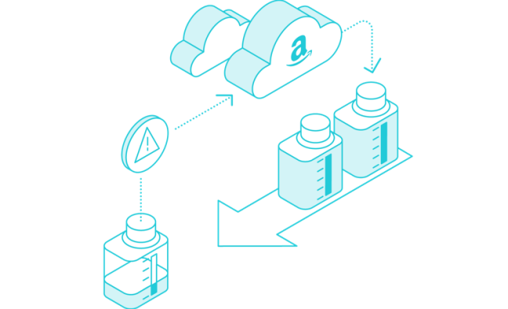**Fig 4.3 AMAZON DRS**

# CHAPTER 5 PROPOSED METHODOLOGY

* 1. **METHODOLOGY:**

Existing replenishment system can only periodically review the inventories. Whereas, current vending machines cannot be capable of providing or determining if the supplies are able to replenishment or not. This results in an inefficient replenishment policy and there will be frequent stock-out among the products. This project aims to provide the automatic replenishment of Smart Vending Machine that will provide and support inventories to the administrator.

**Amazon Dash Replenishment Service (Amazon DRS)** enables when the vending machine is about to run out of the stock inventory/product, it automatically places orders on Amazon, this gives the administrator which of the supplies needed replenishment. By Implementing this project, stock-out among the vending machines will be prevented and an efficient replenishment system can be implemented. We are going to design a vending box which will have three slots each for inventories.

The **Dash Replenishment Service (DRS)** uses **Simple Notification Service (SNS)** Topics to notify you (the device owner) of changes to device status, order state, subscription status, and more. And **Login with Amazon (LWA)** lets you protect your customer information by leveraging the user authentication system used by Amazon.com. Login with Amazon is based on **OAuth 2.0**, which has been broadly adopted for user authorized exchanges across sites. Listed with unique **ASINs (Amazon Standard Identification Number)** of inventories will be mapped with each slot in DRS API.

# BLOCK DIAGRAM:

The block diagram of Smart Vending Machine using Amazon DRS is shown in Fig 5.1, which depicts the overall functioning of the module and proposed system that incorporates IOT based automated system.

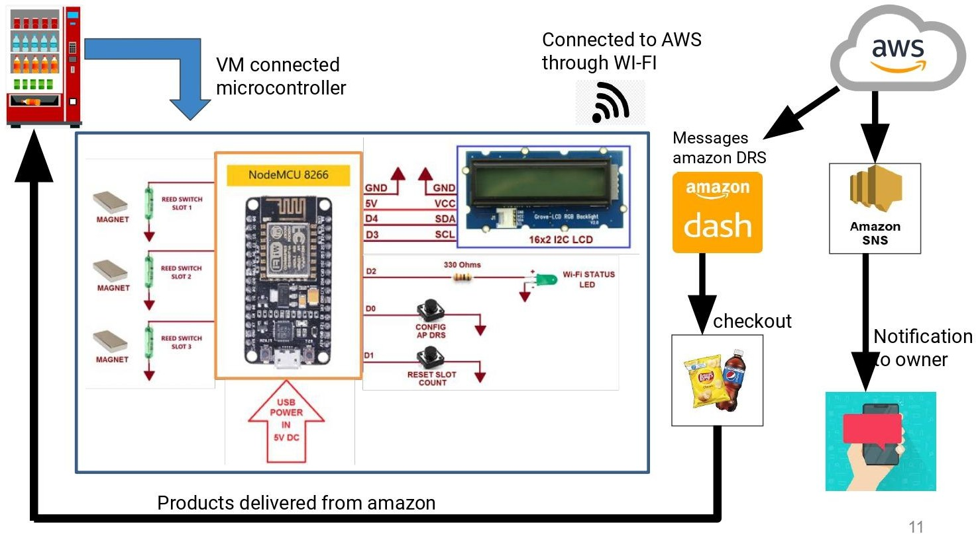

# Fig 5.1 BLOCK DIAGRAM OF THE PROPOSED SYSTEM

* 1. **WORKING OF THE SYSTEM:**

The Block diagram representation of the project is given in the figure 5.1. It simplifies the system into various blocks for better visualization and interpretation. It describes the various blocks of the system and shows which components receive output from the ESP32 and which ones provide an input to the ESP32. In our project ESP32 acts as a Micro-controller. The vending machine will have three slots each for slot1, slot2 and slot3.

Listed with ASINs **(Amazon Standard Identification Number)** of slot1 product will be mapped with slot1, list with ASINs of slot2 will be mapped with slot2 and list with ASINs of slot3 product will be mapped with slot3. Webpage that is linked with Amazon DRS service, so users of the vending box can register and select products for each slot based on their preference using Product ID and serial number of vending machines. The Reed switch is connected to each of the Slot with Neodymium Magnet, which is used for slot counting indicator.

When the slot reaches the minimum threshold value (for example 5 count in slot), then it will send a message/token to Amazon DRS for product replenishment in slots. Also Dash Replenishment Service (DRS) uses SNS Topics to notify you (the device owner) of changes to device status, order state, subscription status, and more. End admin/owner facing web page for Product registration is done separately for the authorization code. All current information (i.e., Tokens, AP Credential, Slot Status) stored in eeprom of ESP32 every time changes. So, on every power cycle, the Vending Machine retains the latest information. Then a successful trigger of the Amazon DRS powered Vending machine enables the admin/owner to check out the product and acknowledgement of the product through the registered mail-id. Then products from Vending machines will be delivered by Amazon.

**5.4 FLOWCHART:**

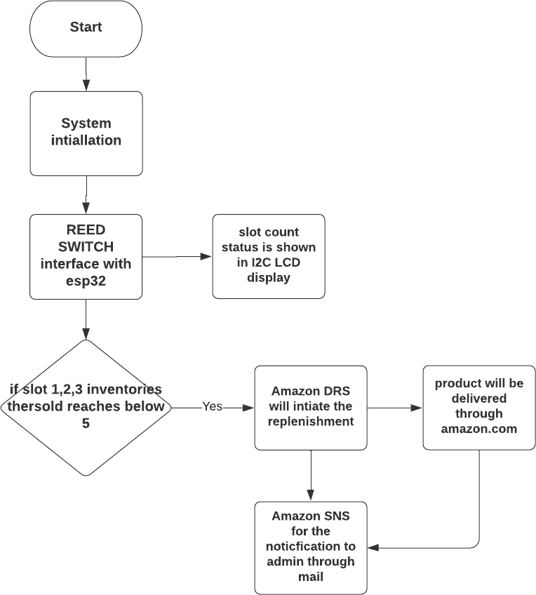

**CHAPTER-6**

**RESULT AND DISCUSSION**

The end customer should register the product with Amazon DRS and generate 20-character Authorization code, so that i have created a Web Page for registering the product from the customer end to Amazon DRS. Once 20 Character Authorization code is generated using the registration process, this code will be used to configure the vending machine to make automatic reordering of products possible without any human efforts.

# Fig 6.1 Product Registration Web Page

Once the config button is pressed on ESP32 it works as an access point (AP) and broadcasts its SSID (SVM). End users can connect to this AP using their mobile phone or personal computer and in the browser it passes the information of

Preferred network SSID, Password and Authorization code generated selecting save option in browser ESP32 automatically connects to preferred network.

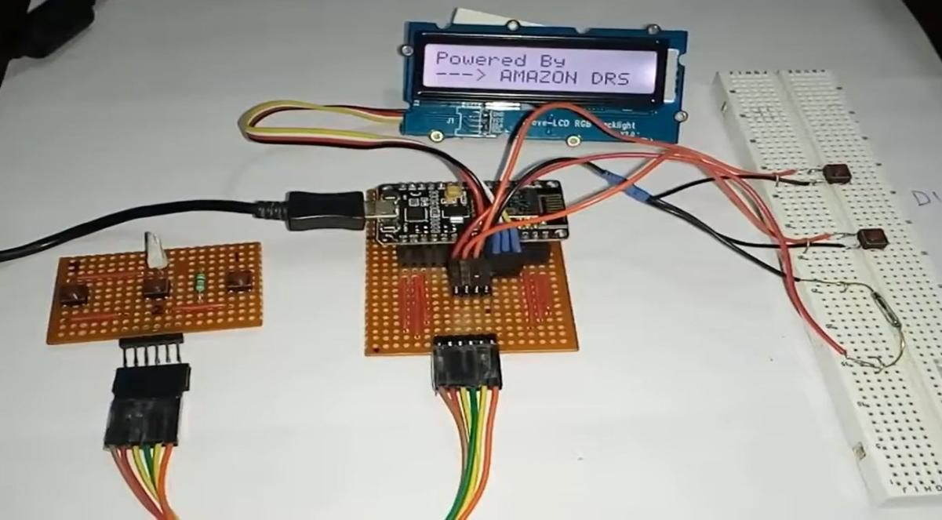

# Fig 6.2 demo photo of project

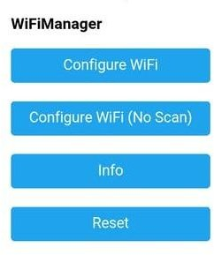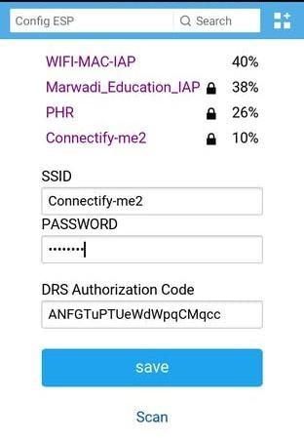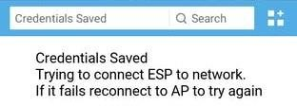Authorization code can be used only once.. And it's valid for about 15 minutes.. this time is not given in Amazon DRS Documentation but in my personal experience it's valid not more than 15 minutes.

# Fig 6.3 config hosted by ESP32

So within 15 minutes it needs to be passed to ESP32 to generate a valid refresh token which is then stored in eeprom for future use to generate access token. Authorization code does not necessarily need to pass every time, and if ESP32 gets a reply from Amazon that authorization code is invalid then ESP32 uses an old refresh token stored in eeprom.

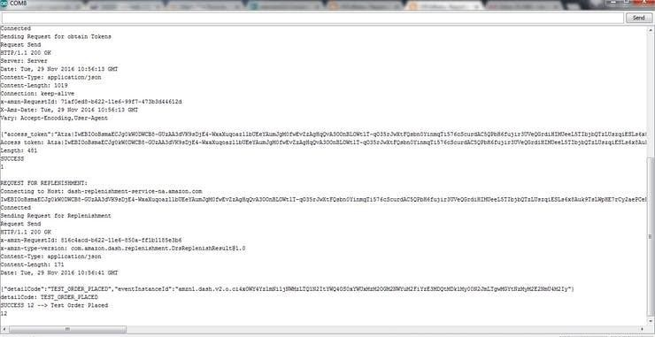

# Fig 6.4 esp32 terminal showing successful replenishment process on trigger of reed switch

# Advantages:

* + - This methodology aims to provide automatic replenishment service to existing vending machines.
    - Utilization of Amazon Dash Replenishment (DRS) Service provides replenishment service
    - User friendly interface enables easy usage by the vending machine.
    - Involvement of cloud computing reduces load and is easily implementable.

**CHAPTER-7**

**CONCLUSION**

The project SMART VENDING MACHINE USING AMAZON DRS using IoT has been implemented successfully and has applications in many ways especially in Vending machines. This is a very advantageous technique which is useful in many ways. **Amazon Dash Replenishment Service (Amazon DRS)** enables when the vending machine is about to run out of the stock inventory/product, it automatically places orders on Amazon, this gives the administrator which of the supplies needed replenishment. Easy to Implement in existing Vending Machines. Reduction of admin/owner and provider gap relation and it is Useful for existing low-cost entry-level Vending Machine. The design of this project enables the existing vending machine into an automatic smart replenishment vending machine with the cost effective.

# 

# REFERENCES

1. Anupama Kaushik **“IOT-An Overview**” , International Journal of Advanced Research in Computer and Communication Engineering, Vol. 5, Issue 3, March 2016.
2. A. H. V. Dela et al., "**Fuzzy logic based replenishment system for smart paper dispensing machine**," 2015 International Conference on Humanoid, Nanotechnology, Information Technology,Communication and Control, Environment and Management (HNICEM), Cebu, Philippines, 2015, pp. 1-7.
3. S. Hutomo, P. Sukarno and R. Yasirandi, "**How Can Fingerprint Improves The Payment Experience of a Drink Vending Machine?,"** 2020 8th International Conference on Information and Communication Technology (ICoICT), Yogyakarta, Indonesia, 2020, pp. 1-6.
4. S. M. S. Arifin et al., **"Smart vending machine based on SMS gateway for general transactions,**" 2017 15th International Conference on Quality in Research (QiR) : International Symposium on Electrical and Computer Engineering, Nusa Dua, Bali, Indonesia, 2017, pp. 34-39.
5. L. Liu, J. Cui, Y. Huan, Z. Zou, X. Hu and L. Zheng, "**A Design of Smart Unmanned Vending Machine for New Retail Based on Binocular Camera and Machine Vision,"** in IEEE Consumer Electronics Magazine.
6. Sooraj P1, Bony Mons2, Dr. Jinsa Kuruvilla3 **“IoT Based Vending Machine with Cashless Payment”** International Research Journal of Engineering and Technology (IRJET) Volume: 06 Issue: 06 | June 2019.
7. **Dash Replenishment Service (DRS):** [https://developer.amazon.com/docs/dash/dash-replenishment-over](https://developer.amazon.com/docs/dash/dash-replenishment-overview.html) [view.html](https://developer.amazon.com/docs/dash/dash-replenishment-overview.html)
8. **Amazon Simple Notification Service(SNS):** [https://aws.amazon.com/sns/?whats-new-cards.sort-by=item.additi](https://aws.amazon.com/sns/?whats-new-cards.sort-by=item.additionalFields.postDateTime&whats-new-cards.sort-order=desc) [onalFields.postDateTime&whats-new-cards.sort-order=desc](https://aws.amazon.com/sns/?whats-new-cards.sort-by=item.additionalFields.postDateTime&whats-new-cards.sort-order=desc)

## [9] Login with Amazon (LWA):

<https://developer.amazon.com/apps-and-games/login-with-amazon>

## [10] Arduino IDE:

[https://www.arduino.cc/en/Tutorial/getting-started-with-ide-v2/ide](https://www.arduino.cc/en/Tutorial/getting-started-with-ide-v2/ide-v2-downloading-and-installing)

## [-v2-downloading-and-installing](https://www.arduino.cc/en/Tutorial/getting-started-with-ide-v2/ide-v2-downloading-and-installing)